**Experiment 01 – Install/configure java development kit (Jdk), android studio,**

**android sdk and AVD**

**Learning Objective:** To install JDK and Android Studio.

**Tools:** Windows 10

**Theory:**

**Android Studio:**

Android Studio is the official integrated development environment (IDE) for Android application development. It is based on the IntelliJ IDEA, a Java integrated development environment for software, and incorporates its code editing and developer tools. To support application development within the Android operating system, Android Studio uses a Gradle- based build system, emulator, code templates, and GitHub integration. Every project in Android Studio has one or more modalities with source code and resource files. These modalities include Android app modules, Library modules, and Google App Engine modules.

It is an open-source software platform and operating system for mobile devices which is based on the Linux kernel. It was developed by Google and later by the Open Handset Alliance (OHA). It allows writing managed code in the Java language and Kotlin language. It has its own virtual machine i.e., DVM (Dalvik Virtual Machine), which is used for executing the android application.

Android is a multi-process system, in which each application (and parts of the system) runs in its own process. Most security between applications and the system is enforced at the process level through standard Linux facilities, such as user and group IDs that are assigned to applications. It uses an Instant Push feature to push code and resource changes to a running application. A code editor assists the developer with writing code and offering code completion, refraction, and analysis. Applications built in Android Studio are then compiled into the APK format for submission to the Google Play Store.

**Java Development Kit:**

The Java Development Kit (JDK) is a software development environment that offers a collection of tools and libraries necessary for developing Java applications. One need to the JDK to convert your source code into a format that the Java Runtime Environment (JRE) can execute. The JDK includes the Java Runtime Environment (JRE), an interpreter (java), a compiler (javac), an archiver (jar), a documentation generator (javadoc), and some other development tools. The Java Runtime Environment itself consists of the Java Virtual Machine (JVM), supporting files, and core classes.

**Android Software Development Kit:**

Android software development is the process by which applications are created for devices running the Android operating system. The Android SDK is a collection of software development tools and libraries required to develop Android applications. Every time Google releases a new version of Android or an update, a corresponding SDK is also released which developers must download and install. It is worth noting that you can also download and use the Android SDK independently of Android Studio, but typically you'll be working through Android Studio for any Android development. The Android software development kit (SDK) includes a comprehensive set of development tools. These include a debugger, libraries, a handset emulator based on QEMU, documentation, sample code, and tutorials. These tools provide a smooth flow of the development process from developing and debugging, through to packaging.

**Android Virtual Device:**

The Android Emulator simulates Android devices on computer so that one can test their application on a variety of devices and Android API levels without needing to have each physical device. The emulator provides almost all of the capabilities of a real Android device. It can simulate incoming phone calls and text messages, specify the location of the device, simulate different network speeds, simulate rotation and other hardware sensors, access the Google Play Store, and much more. An Android Virtual Device (AVD) is a configuration that defines the characteristics of an Android phone, tablet, Wear OS, Android TV, or Automotive OS device that you want to simulate in the Android Simulator. The AVD Manager is an interface you can launch from Android Studio that helps you create and manage AVDs. An AVD contains a hardware profile, system image, storage area, skin, and other properties.

**Implementation:**

Download the android studios from the site.

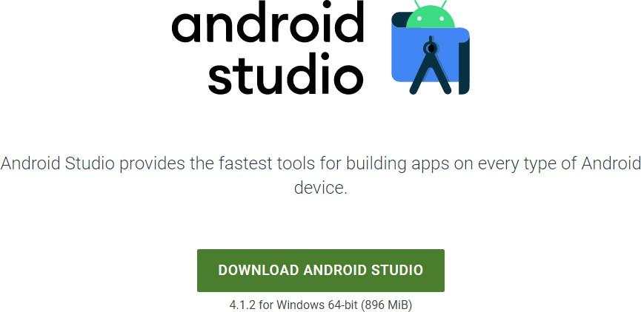

After the downloading has finished, open the file from downloads and run it.

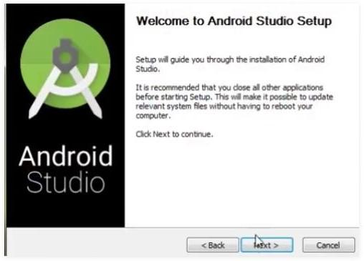

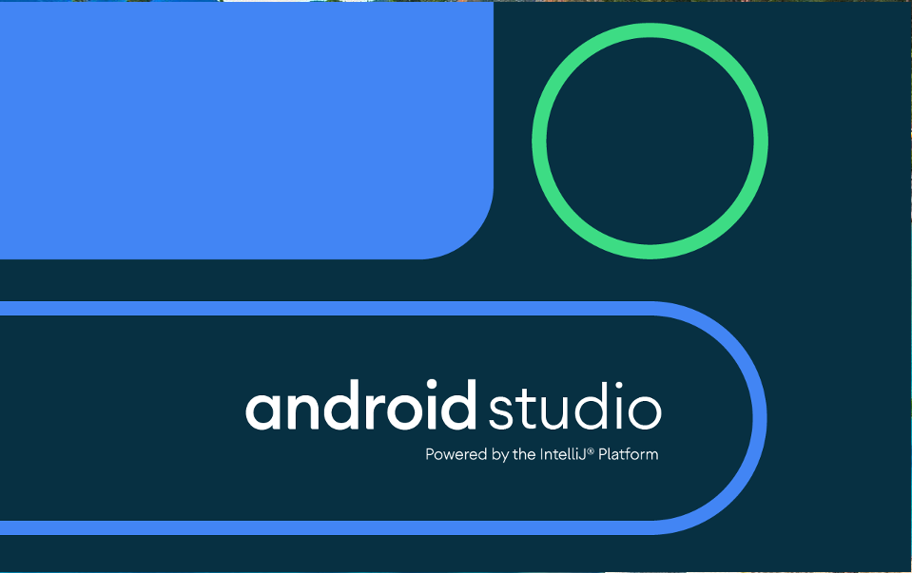After completing the installation process, the application opened.

Create a new project

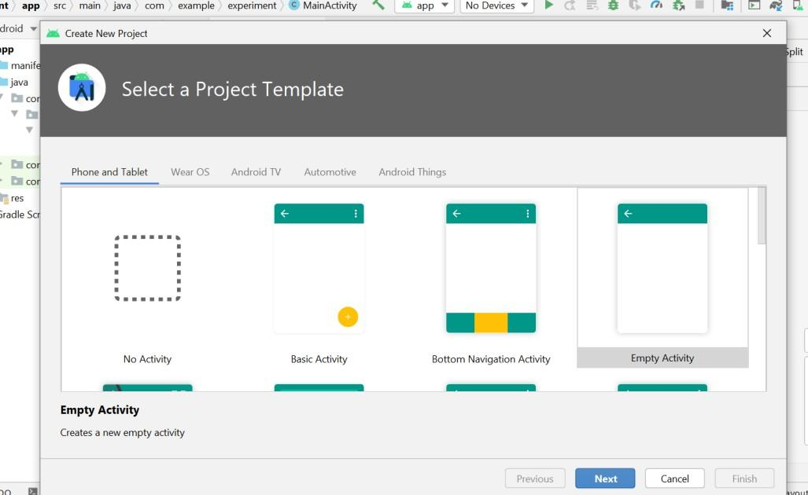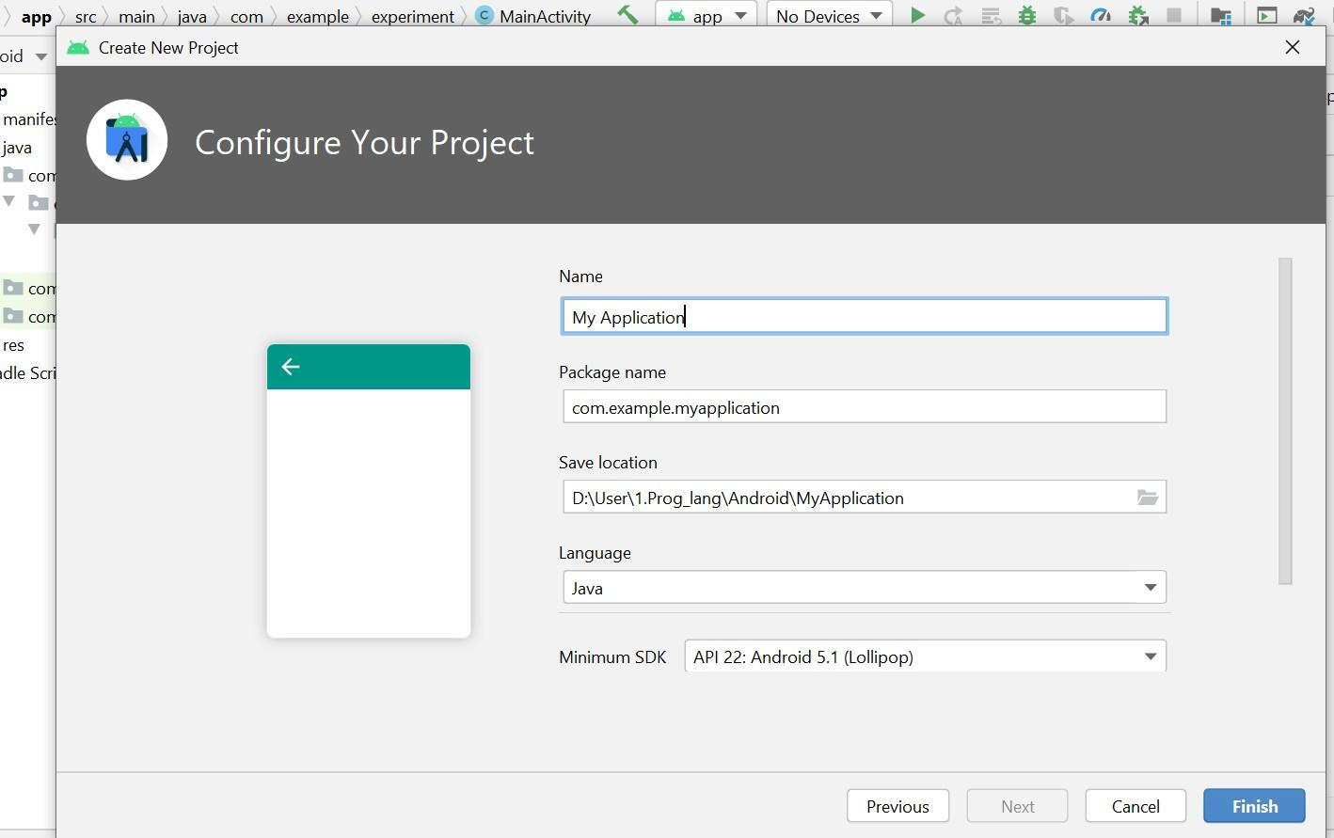

**Result and Discussion:** After performing this experiment I was able to explain the steps for installation and set-up of jdk, for installation of Android Studio and create Virtual Device within Android Studio

**Learning Outcomes:** The student should have the ability to

LO1: **explain** the steps for installation and set-up of jdk.

LO2: **explain** the steps for installation of Android Studio

LO3: **create** Virtual Device within Android Studio

**Course Outcomes:** Upon completion of the course students will be able to understand the setup of jdk and Android Studio.

**Conclusion:**

We learnt in this experiment the theory of android studios, Java development kit, android software development kit and android virtual devices. We also studied that JDK is a development environment that uses the JAVA programming language to create software, applets, and components. Android Studio is an IDE which, using Java Programming, is used for simple and seamless app construction. On any form of Android device, Android Studio offers the quickest tools for developing applications. The Android SDK contains all the tools required for scratching and even checking programs. AVD is used to run Android Studio- developed software, allowing for simpler testing. All the necessities appropriate for construction applications have also been installed.

For Faculty Use

|  |  |  |  |  |
| --- | --- | --- | --- | --- |
| **Correction Parameters** | **Formative Assessment [40%]** | **Timely completion of Practical [ 40%]** | **Attendance / Learning Attitude [20%]** |  |
| **Marks Obtained** |  |  |  |